**useParams**

what is useParams?

= useParams is a react hook to get the params from a route

How we can get useParams

This is params

First in app.js write the code



After that, go to the user.js component and write the code

import React from 'react'

import { useParams } from 'react-router-dom'

export default function Users() {

Get userID from useParams()

        let {userID}=useParams()

  return (

    <div>

        <h1>{userID}</h1>

    </div>

  )

}

Output:  
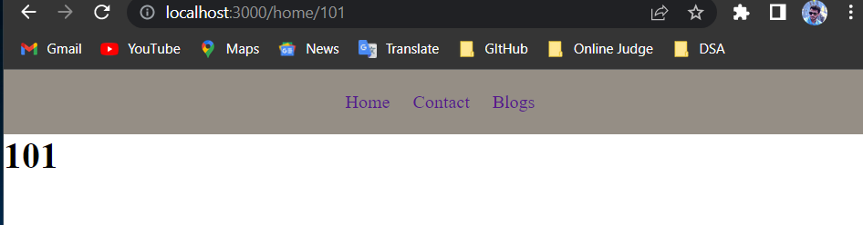

**useSearchParams**

what is useSearchparams?

= useSearchParams is a react hooks to get and send query in the search bar in a browser

This is how we see query in the search bar

http://localhost:3000/query?name=ibrahim&id=1&body=live+in+bd

How do I use this useSearchParams hook?

1st create a query.js file



Then go to the app.js and add a route using query component



After that go to the query.js file and write the code

import React, { useState } from 'react'

import { useSearchParams } from 'react-router-dom'

1.Create a useSearchParams hook

export default function Query() {

    let [searchParams,setSearchParams]=useSearchParams()

2.Create some state named name, id, body

    const [name, setname] = useState("");

    const [id, setid] = useState('');

    const [body, setbody] = useState('');

    let handleSubmit=()=>{

        setSearchParams({name:name, id:id})

4. set the searchParams as object name,id

    }

  return (

    <div>

        <h4>Now we will learn how to use query</h4>

        <br />

        <form action="" onSubmit={handleSubmit}>

3. Set the changed value in the name state

            <div>

                <label htmlFor="name">Name:</label>

                <input type="text" id='name' name="name" onChange={(e)=>{

                    setname(e.target.value)

                }} />

            </div>

            <button type="submit">Submit</button>

        </form>

5.Get the query values using searchParams.get(“name”)

        <h3>{searchParams.get("name")}</h3>

    </div>

  )

}

**Output**:

Before submitting:

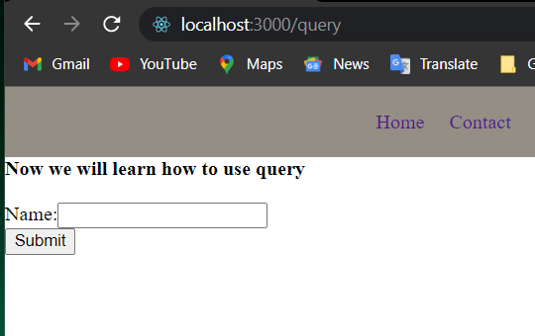

After submitting:

